**Experiment / Assignment / Tutorial No. 3**

**Grade: AA / AB / BB / BC / CC / CD /DD**

**Signature of the Staff In-charge with date**

|  |
| --- |
| **Batch: B1 Roll No.: 1711072 Experiment / Assignment / Tutorial No.: 3** |

|  |
| --- |
| **Title:** Design 4:1 Multiplexer and 1: 4 De-multiplexer |

**______________________________________________________________________________**

**Objective:** To design and implement a 4:1 multiplexer and 1:4 de-multiplexer using logic gates and MUX IC

**______________________________________________________________________________**

**Expected Outcome of Experiment:**

**CO2:** Use different minimization technique and solve combinational circuits, synchronous & asynchronous sequential circuits.

**______________________________________________________________________________**

**Books/ Journals/ Websites referred:**

* R. P. Jain, “Modern Digital Electronics”, Tata McGraw Hill
* M .Morris Mano, “Digital Logic & computer Design”, PHI
* [https://wiki.engr.illinois.edu/download/attachments/84770821/08](https://wiki.engr.illinois.edu/download/attachments/84770821/08-Multiplexers.pdf?version=2&modificationDate=1285128827000)- [Multiplexers.pdf?version=2&modificationDate=128512882700](https://wiki.engr.illinois.edu/download/attachments/84770821/08-Multiplexers.pdf?version=2&modificationDate=1285128827000)0

**Pre Lab/ Prior Concepts:**

**Multiplexer:** Multiplexer is a special type of combinational circuit. It is a digital circuit which selects one of the n data inputs and routes it to the output. The selection of one of the n inputs is done by the select lines. To select n inputs we require m select lines, such that 2m=n. Depending on the digital code applied at the select inputs, one out of the n data sources is selected and transmitted to a single output . E is called as the strobe or enable input which is useful for cascading. It is generally on active low terminal that means it will perform the required operation when it is low. The multiplexer act like a digitally controlled single pole, multiple way switches. The output gets connected to only one input at a time. In most of the electronic system the digital data is available on more than one line. It is necessary to route the data over a single line, under such circumstances input at a time

**Types of Multiplexer:**

1. 2:1 Multiplexer
2. 4:1 Multiplexer
3. 8:1 Multiplexer
4. 16:1 Multiplexer
5. 32:1 Multiplexer

**De-multiplexer:** It has only one input, n output and m select lines. A demultiplexer performs the reverse operation of a multiplexer i.e. it receives one input and distributes it over several outputs. The demultiplexer converts a serial data signal at the input to a parallel data at its output lines. The relation between the output lines and select lines is as follows: N=2m

**Types of Demultiplexers:**

1. 1:2 DEMUX
2. 1:4 DEMUX
3. 1:8 DEMUX
4. 1:16 DEMUX

**Implementation Details of 4:1 MUX**

**Block Diagram of 4:1 MUX**

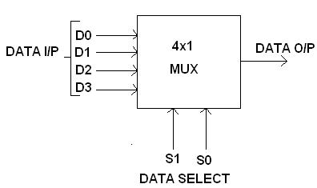

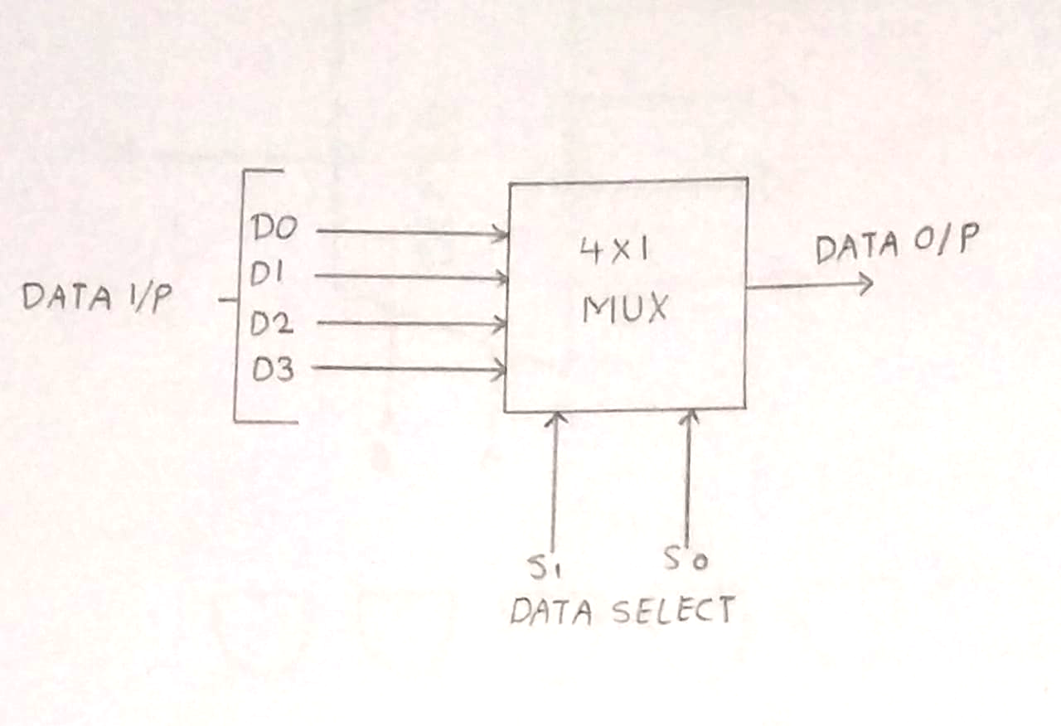

**Circuit Diagram of 4:1 MUX**

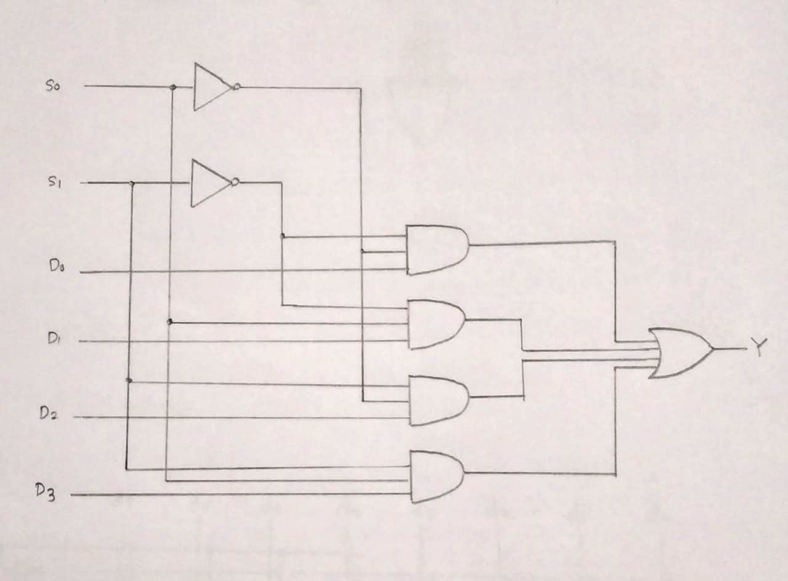

**Truth table**

|  |  |  |
| --- | --- | --- |
| **S1** | **S0** | **Y** |
|  |  |  |
| 0 | 0 | D0 |
|  |  |  |
| 0 | 1 | D1 |
|  |  |  |
| 1 | 0 | D2 |
|  |  |  |
|  |  |  |
| 1 | 1 | D3 |
|  |  |  |

**From Truth Table:**

Y = D0 S1’ S0’ + D1 S1’ S0 + D2 S1 S0’ + D3 S1 S0

**Implementation Details of 8:1 MUX**

**Circuit Diagram of 8:1 MUX**

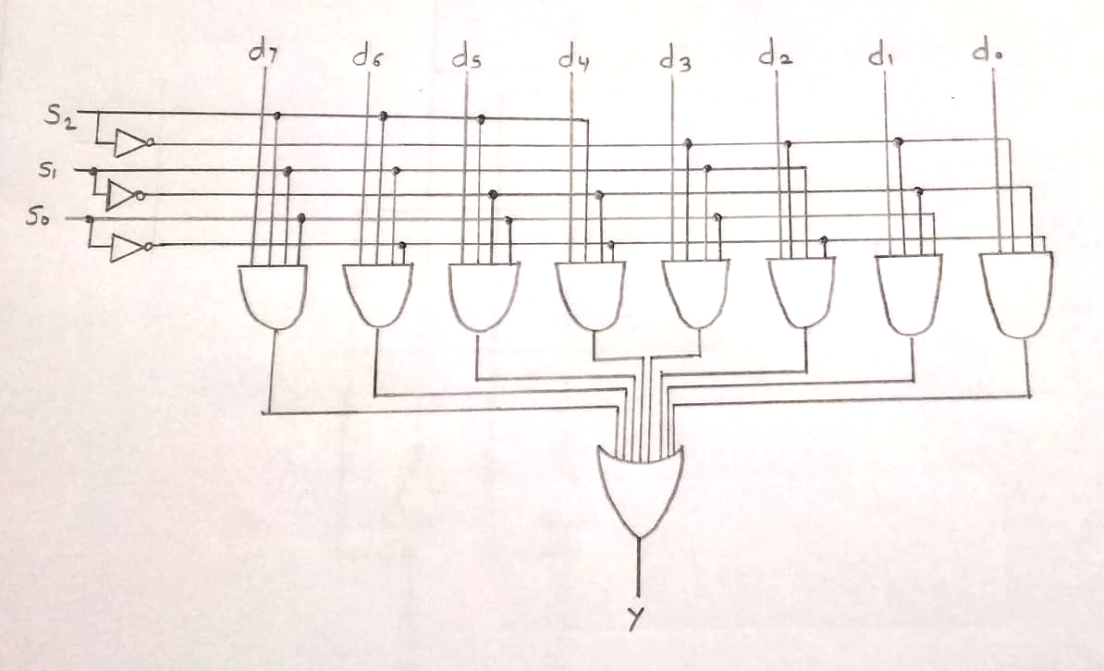

**Truth Table for 8:1 Multiplexer**

|  |  |  |  |
| --- | --- | --- | --- |
| **S2** | **S1** | **S0** | **Y** |
| **0** | **0** | **0** | **D0** |
| **0** | **0** | **1** | **D1** |
| **0** | **1** | **0** | **D2** |
| **0** | **1** | **1** | **D3** |
| **1** | **0** | **0** | **D4** |
| **1** | **0** | **1** | **D5** |
| **1** | **1** | **0** | **D6** |
| **1** | **1** | **1** | **D7** |

**From Truth Table:**

**Y =** D0 S2’ S1’ S0’ + D1 S2’ S1’ S0 + D2 S2’ S1 S0’ + D3 S2’S1 S0 + D4 S2 S1’ S0’ + D5 S2 S1’ S0 + D6 S2 S1 S0’ + D7 S2 S1 S0

**Pin diagram: IC 74151**

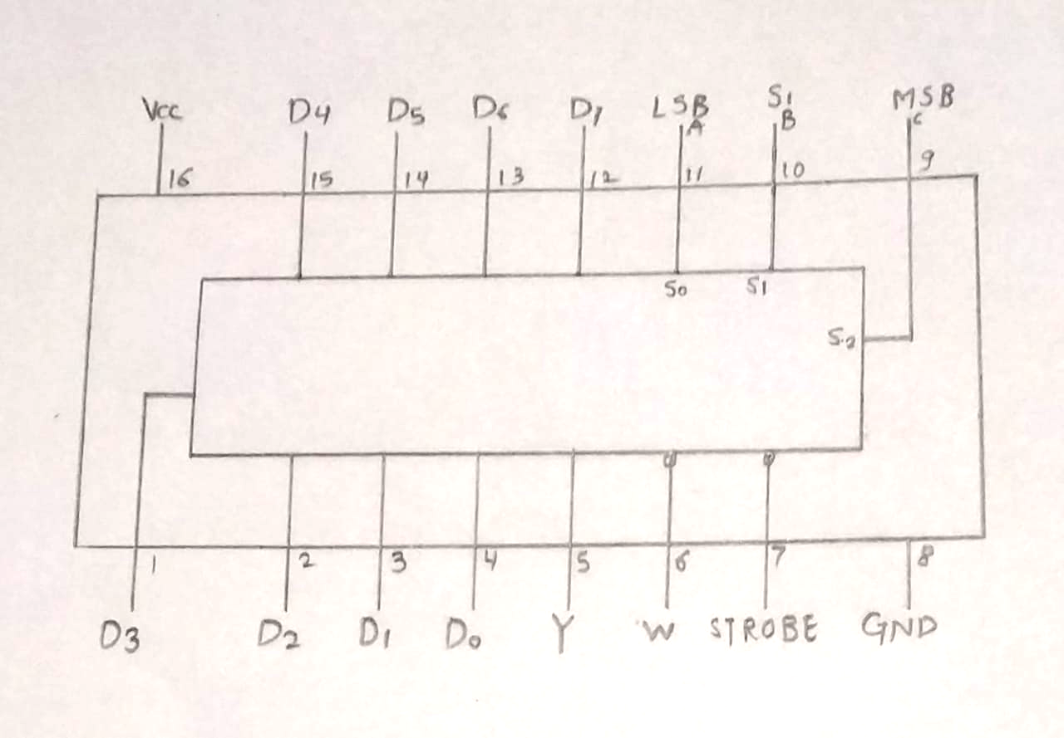

**D0- D7**: Inputs

**A, B, C**: Select lines

**STROBE, GND**: ground

**Vcc** = + 5V

**Y**: Non-inverting output

**W**: Inverting output

**Block Diagram of 1:4 DE MUX**

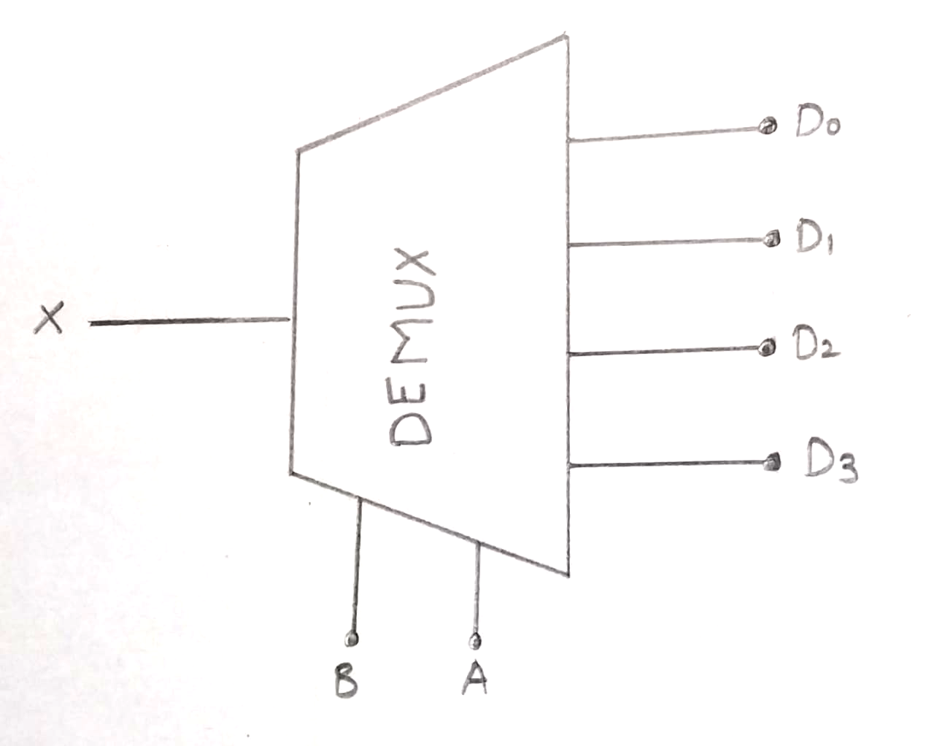

**Circuit Diagram of 1:4 DE MUX**

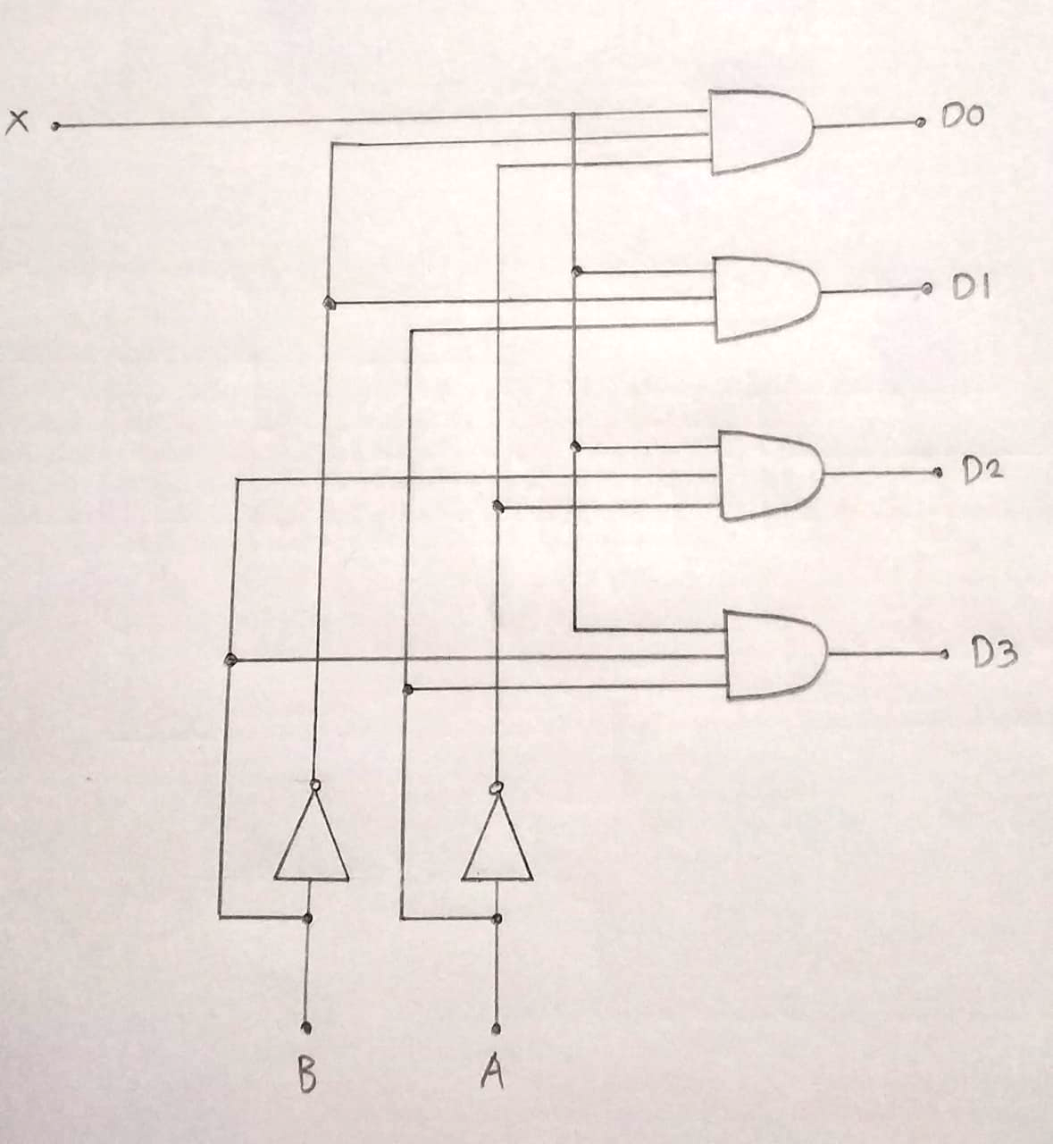

**Truth Table for 1:4 Demultiplexers**

|  |  |  |  |  |  |
| --- | --- | --- | --- | --- | --- |
| **B** | **A** | **D0** | **D1** | **D2** | **D3** |
| **0** | **0** | **X** | **0** | **0** | **0** |
| **0** | **1** | **0** | **X** | **0** | **0** |
| **1** | **0** | **0** | **0** | **X** | **0** |
| **1** | **1** | **0** | **0** | **0** | **X** |

**From Truth Table:**

D0 =A’B’X

D1 =A’BX

D2 =AB’X

D3 =ABX

**Conclusion:**

Thus, we learned about the multiplexer (4:1, 8:1) and de-multiplexer (1:4) circuits and tested them on the trainer kit and verified their working for various test cases.

**Post Lab Descriptive Questions**

1. How many select lines are required for 64:1 MUX?

Ans. For 64:1 MUX, as per the relation 2Select Lines=Number of inputs. So, number of select lines (S) that will be needed will be log2n where n is 64. So, S= log264=6.

1. State some applications of MUX and DEMUX.

Ans. **Applications of Multiplexer:**

#### Multiplexer are used in various fields where multiple data need to be transmitted using a single line. Following are some of the applications of multiplexers –

1. ***Communication system***: Communication system is a set of system that enables communication like transmission system, relay and tributary station, and communication network. The efficiency of communication system can be increased considerably using multiplexer. Multiplexer allow the process of transmitting different type of data such as audio, video at the same time using a single transmission line.
2. ***Telephone network*:**In telephone network, multiple audio signals are integrated on a single line for transmission with the help of multiplexers. In this way, multiple audio signals can be isolated and eventually, the desire audio signals reach the intended recipients.
3. ***Computer memory*:** Multiplexers are used to implement huge amount of memory into the computer, at the same time reduces the number of copper lines required to connect the memory to other parts of the computer circuit.
4. ***Transmission from the computer system of a satellite:*** Multiplexer can be used for the transmission of data signals from the computer system of a satellite or spacecraft to the ground system using the GPS (Global Positioning System) satellites.

**Applications of Demultiplexer:**

1. Demultiplexer is used to connect a single source to multiple destinations. The main application area of demultiplexer is communication system where multiplexer are used. Most of the communication systems are bidirectional i.e. they function in both ways (transmitting and receiving signals). Hence, for most of the applications, the multiplexer and demultiplexer work in sync. Demultiplexers are also used for reconstruction of parallel data and ALU circuits.
2. ***Communication System:*** Communication system use multiplexer to carry multiple data like audio, video and other form of data using a single line for transmission. This process makes the transmission easier.  The demultiplexer receives the output signals of the multiplexer and converts them back to the original form of the data at the receiving end. The multiplexer and demultiplexer work together to carry out the process of transmission and reception of data in communication system.
3. ***ALU (Arithmetic Logic Unit):*** In an ALU circuit, the output of ALU can be stored in multiple registers or storage units with the help of demultiplexer. The output of ALU is fed as the data input to the demultiplexer. Each output of demultiplexer is connected to multiple register which can be stored in the registers.
4. ***Serial to parallel converter:*** A serial to parallel converter is used for reconstructing parallel data from incoming serial data stream.  In this technique, serial data from the incoming serial data stream is given as data input to the demultiplexer at the regular intervals. A counter is attached to the control input of the demultiplexer. This counter directs the data signal to the output of the demultiplexer where these data signals are stored. When all data signals have been stored, the output of the demultiplexer can be retrieved and read out in parallel.
5. Build a 4:1 MUX using only 2:1 MUX.

Ans.

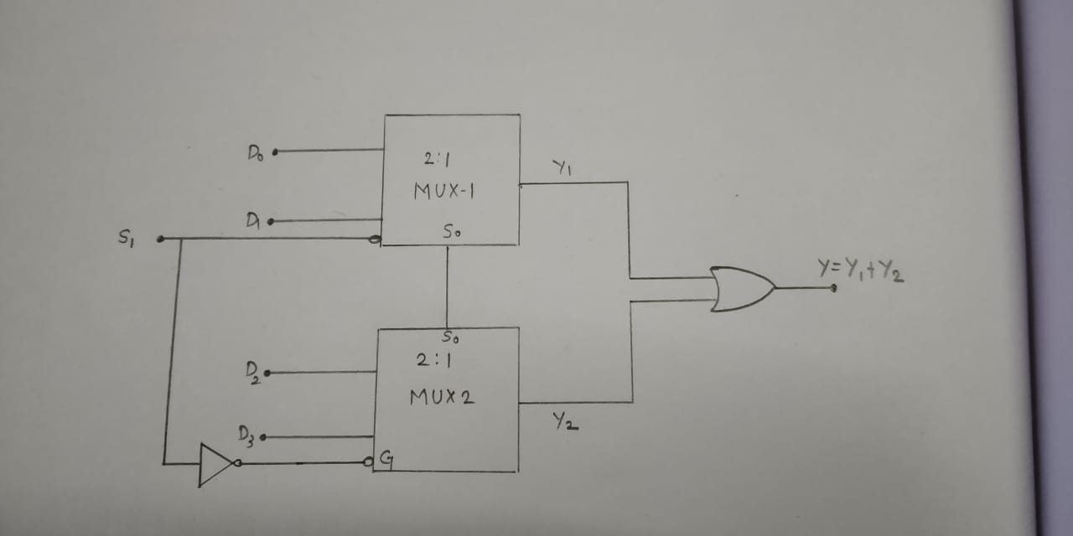

This has been done with two 2:1 MUXes by using the STROBE for cascading.